«Teaching basic sciences to young people with fewer opportunities towards inclusive education»
Ref. no. «2018-01-FR01-KA201-048198».
Baudreix, France, 1st – 5th April 2019.
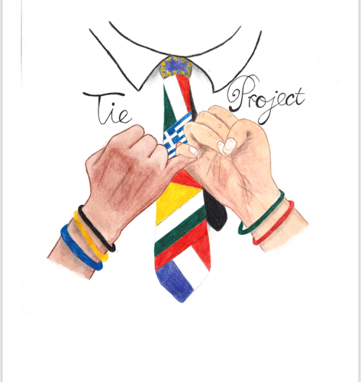
Mobility report

TIE project partners have held their second blended mobility of school learners in the LTP Nay-Baudreix, France from April 1st to April 5th, 2019. The participants were 35 students and 10 teachers from 5 schools came together as part of the theme “Chemistry in Food and Wine”.
The schools that participated were :
1. PGEB “ prof. D-r Asen Zlatarov” from Bulgaria
2. Liceo Benedetto Groce from Italy
3. ITA Emilio Sereni from Italy
4. 1st EPAL Thessalonlikis from Greece
5. LTP Nay Baudreix from France as host school for this project meeting

The objectives of the meeting were:
- To promote social inclusion
- To promote the acquisition of basic skills and competences in chemistry through effective and innovative teaching
- To encourage critical thinking
- To help teachers adopt collaborative and innovative practices
- To enable the participation of immigrant students
- To develop students’ competence in English language
- To develop their digital skills,
- To communicate with each other
- To work as part of a multinational group
- To create common sense of European citizenship
- To understand and be tolerant towards differences between cultures, people and religions

To achieve those goals in the context of the project, the host school organized:
- Presentations about the cities, countries and schools
- Presentations of the scientific projects that the schools prepared in connection with the specific theme of this study week.
- All the students were together in the boarding school, in order to communicate.
- Chemistry, Biology and microbiology workshops in the theme of the week
- Cultural visits in the area
- Visits of a local productor of an AOC sheep cheese.
- Visit of a winery
- A meeting with local authorities at the town hall
- An evening party at school with music prepared by all participating schools
- A farewell dinner
In detail:

Day 1: Monday, April 1st:
The week started with the welcome meeting with coffee and orange juice for all. Then school and cities presentation were done. After the lunch at school, we’ve done a pedestrian city tour of Pau, the weather was good, and all the students could appreciate the city. A group photo was done around the Castle of Pau.
Day 2: Tuesday, April 2nd:
The schools presented their chemistry projects. They all worked hard to prepare them and the result was really rewarding.
After the presentations everyone enjoyed the lunch, and we visited a wine producer at Jurançon. Then, we went to visit the 2nd school site (Equestrian activities, Horticulture…) and at 7:30 PM all the students and the teachers participate at a Buffet with executive board school and local authorities.
Day 3: Wednesday, April 3rd :
A day trip to Bask Country, was organised . The visit of Bayonne, with this particular houses,, the beautiful town of Biarritz, Rocher de la Vierge, Boulevard de la Mer with the Palais of Eugénie and a lunch to a local restaurant. The weather was not great, and our host knew why the bask country has a green landscape…
Day 4: Thursday, February 4th:
There were three kinds of workshops for the students. The students were mixed together in order to create European teams, they communicated in English, and they participated to all activities. Chemistry workshops took place in the chemistry lab of our school. They were able to determinate lactic acid in the fresh milk. In the Biology Lab, the detected antibiotics in the milk, and in the microbiology lab they worked on the detection of E.Coli in the milk. For the youngest, it was the first time they could manipulate in a Lab. They were enjoyed by the lab activities.
After the lunch in the school, they visited a cheese producer in the Pyrénées‘ mountain. They could touch animals, and taste the cheese.
After the dinner, the boarding educator prepared a Karaoke party, and they enjoyed dancing until late at the evening.
Day 5: Friday, April 5th:
This last day included a visit of Lourdes, with a movie, in English language to understand the life of Bernadette Soubirou. After a visit of the Grotte they could have free time in the city.
A farewell party was held , in a restaurant around the school, with lots of food, and music.. The certificates of attendance were awarded to the participants and they all had a chance to spend some time together sharing experiences, memories and talks about the week they spent together.
In conclusion, it was a pleasure to meet our partners in Baudreix, France, to work with them and meet all the objectives connected with the project.
Baudreix April 6th 2019 Chantal GELIZE Erasmus Coordinator

